**Name of Student: Ramit Bose**

**Reg.No.: 21BCE1316**

**Ex. No:5**

**Date :10-03-2023**

**Requirement Modeling using State Transition Diagram**

Aim:

Preparing the State Transition Diagram for my application i.e., ATM Management System in StarUML.

Description:

Describing the logical transition of a system through various states of operation by representing states, the transitions that connect them, and the events that trigger transitions.

Output Screenshot:

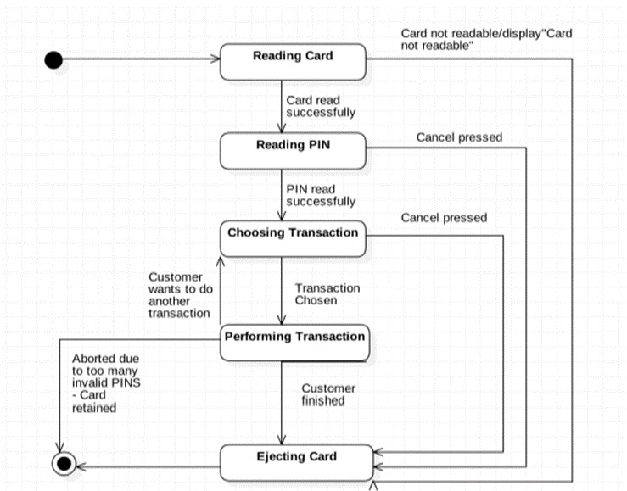

Result:

Hence, we have made the state transition diagram for our project ATM Management System